|  |
| --- |
| [Click on the specific symbol to view its symbolism  [coatofarms.gif 22315 bytes)](http://www.gov.za/_vti_bin/shtml.dll/symbols/coatofarms.htm/map) |
|  |

**EMBASSY OF SOUTH AFRICA  
RUSKA 65, 100 00 PRAGUE 10**

**NEWSLETTER - FEBRUARY 2016 (No.2 )**

[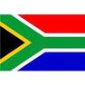](http://www.google.co.za/imgres?imgurl=http://sasportswear.co.za/images/sportswear/south_african_storm_flag.jpg&imgrefurl=http://sasportswear.co.za/sa-memorabilia-7/sports-flags-21/south-african-flag-storm-72.html&h=591&w=591&sz=35&tbnid=Uv7cCdEcYE0-pM:&tbnh=135&tbnw=135&prev=/images?q=South+African+flag&hl=en&usg=__g8gihHXhaZlPhuEToAfXga4s4Hw=&sa=X&ei=IslOTK-nNo-R4Qay7dWoCA&ved=0CAgQ9QEwAQ)



**WORD BY THE AMBASSADOR**

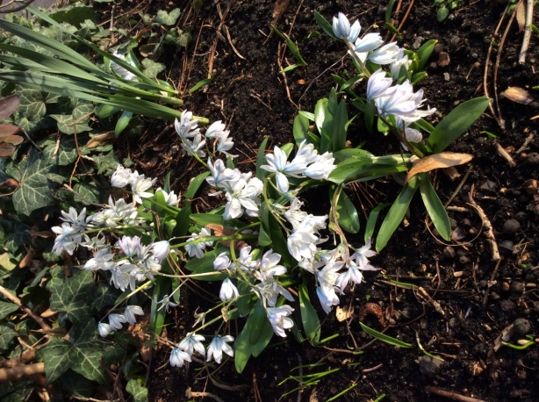 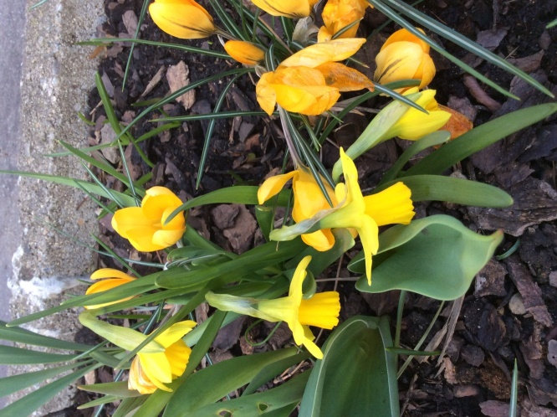

It would appear that nature is as confused in the Czech Republic as elsewhere in the world. While February is the last month of winter, we experienced a mix of snow, icy winds and almost balmy temperatures in Prague. Spring flowers appeared and some trees started blossoming, more than a month in advance.

Despite the early signs of spring, it was still wintry enough for the guests at the joint Embassy-SAA event to enjoy being transported to warmer climates during the guided tour of the glass houses at the Prague Botanical Garden where some species from South Africa’s indigenous plant kingdom are being grown and displayed.

I had an opportunity to visit Liberec in February, a visit I had long looked forward to. I was very hospitably received and particularly enjoyed the view from roof terrace of the Regional Government building over the undulating forested countryside around the city with the mountain range in the background.

**EMBASSY NEWS**

***Traditional Reception of Mayor of Prague***

[](http://www.praha.eu/jnp/en/index.html)The annual New Year’sreception for the Diplomatic Corps was hosted by the Mayor of Prague Ms Adriana Krnáčová on 2 February 2016 at the Mayor’s Residence.

***Visit to Liberec***

The Ambassador visited the town of Liberec on 8 February 2016 to meet the representatives of the Liberec Region, visit the Technical University of Liberec and to meet the Mayor of the city to promote South Africa and discuss possible cooperation.

[Description: Image result for liberecky kraj logo](http://www.google.cz/url?url=http://www.i-noviny.cz/liberecky-kraj-ma-nove-logo-15279&rct=j&frm=1&q=&esrc=s&sa=U&ved=0ahUKEwjfq42YiZ3LAhWm73IKHVVEBCsQwW4IFjAA&usg=AFQjCNFgzWFq9FM-jG7QL430L3cc7L7_9g)[](http://www.google.cz/url?url=http://www.esn-liberec.cz/partners/technical-university-liberec&rct=j&frm=1&q=&esrc=s&sa=U&ved=0ahUKEwj2l-DZiZ3LAhXk83IKHWW1AsIQwW4IIDAF&usg=AFQjCNH8qYkUG6QxEa5d025DaoTaA5qB0A) [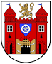](http://www.google.cz/url?url=http://www.liberec.cz/cz/mesto-samosprava/zakladni-kontaktni-udaje/&rct=j&frm=1&q=&esrc=s&sa=U&ved=0ahUKEwiMgPCRip3LAhUlmHIKHUz1AFYQwW4IHjAE&usg=AFQjCNGVpilrNwYUiddiy5lrQUHt8UM5ZQ)

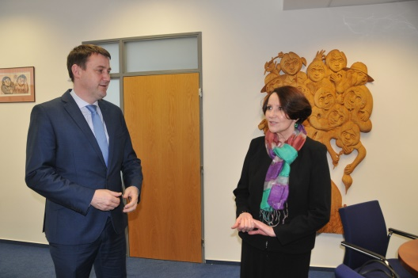

*Governor of the Region Mr Martin Půta welcomes the Ambassador in his office, 8 February 2016*

*Picture: Governor’s Office//Markéta Dědková*

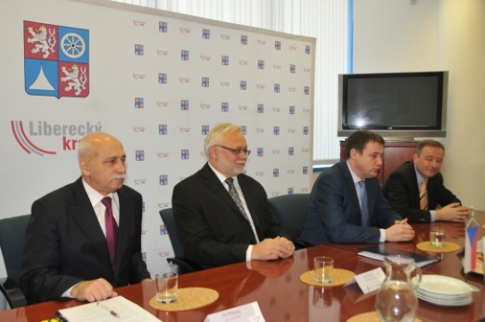

*Mr Vít Příkask*ý, *Mr Josef Jadrný (Vice-Governor), Mr Martin Půta (Governor), and Mr Josef Chýle give a briefing on the Region*

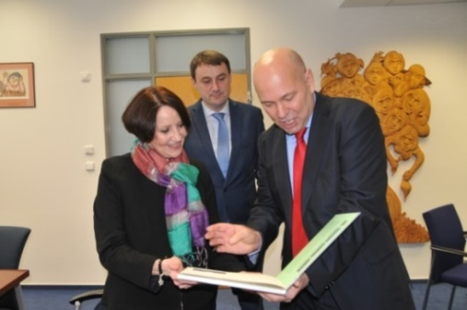

*Mr Miloš Pavlů presents a book on Pavlů-Complex company* *to the Ambassador. The company has an operation in South Africa with 50 employees.*

*Pictures: Governor’s Office/Markéta Dědková*

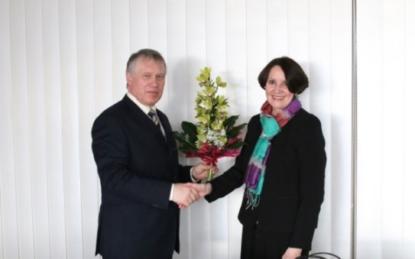

*Rector of Technical University of Liberec (TUL)*

*Prof Dr Ing Zdeněk Kůs meets Ambassador Verwey*

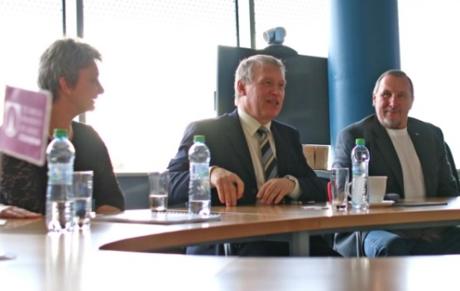

*Dr Jana Drašarová, Dean of Textile Faculty, Prof Zdeněk Kůs, Rector and Prof. Jiří Militký.*

*Pictures: Radek Pirkl, TUL*

In the past, the Technical University of Liberec closely cooperated with the RSA. Three groups of South African students graduated in Master studies of Textile Engineering and seven groups attended short-term Professional Development studies between 2006 and 2011.

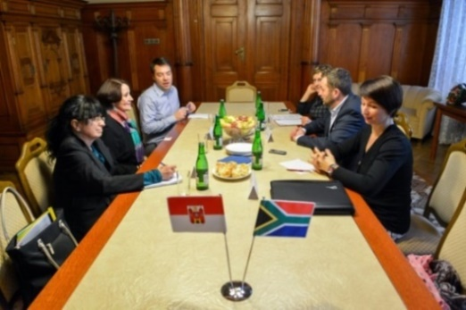

*Ms Zdenka Herclová, Ambassador Verwey, Mr Jan Svoboda, Ms Miluše Charyparová, Mayor of Liberec Mr Tibor Batthyány and Ms Jana Kodymová*

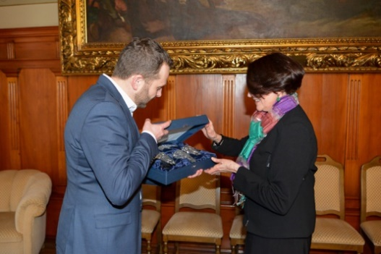

*Mayor of Liberec Mr Tibor Batthyány presents Czech glass to Ambassador Verwey. Pictures:**MML/Jan Král*

[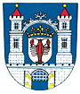](https://en.wikipedia.org/wiki/File:Rakovnik_znak.jpg)***Visit to Rakovník***

On 18 February 2016 the Ambassador attended a visit to Rakovník organized for the Diplomatic Corps by Ms Jaroslava Jermanová, 1st Vice-President of the Chamber of Deputies of the Parliament. The delegation met representatives of the town, visited Zikmund Winter Grammar School, Procter & Gamble Company and traditional Brewery Bakalář.

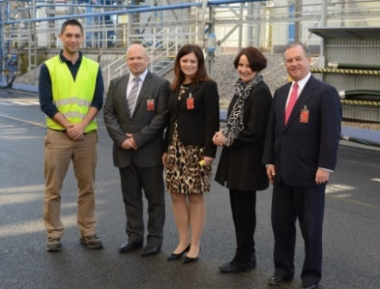

*Ambassador Verwey, MP Jaroslava Jermanová and Ambassador of Mexico with representatives of Rakovník. Picture: Parliament of ČR*

***SA Embassy – SAA Joint event***

The Embassy, in co-operation with the representative of South African Airways (SAA) in the Czech Republic, organized a tourism promotional event on 18 February 2016 for Czech tour operators and travel agencies.

**[](http://www.zoojihlava.cz/)***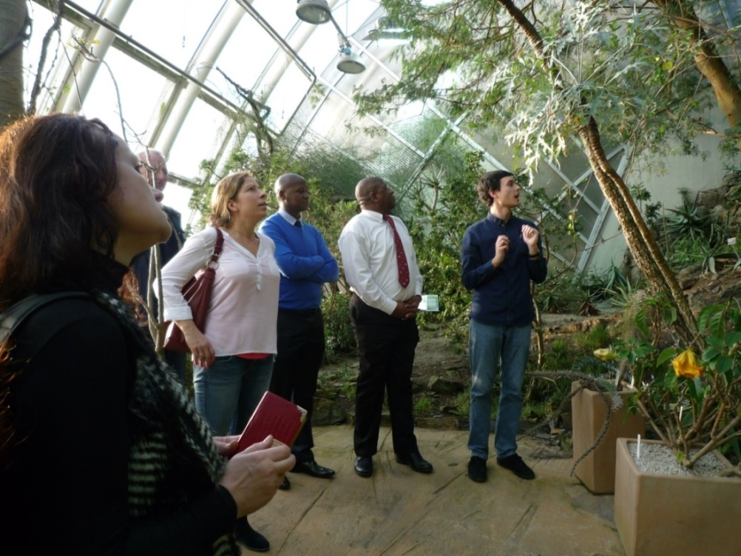*

*Mr Ncongwane and Mr Dasa during the guided tour of the Greenhouses at the Botanical Garden of Prague* *which houses a collection of indigenous South African plants*

The tour of the Botanical Garden was followed by a presentation on the services offered by SAA, a wine tasting and buffet dinner.

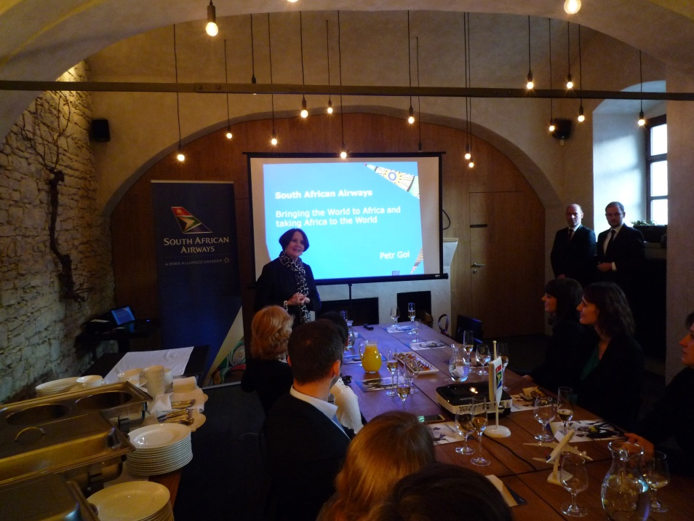

*The Ambassador welcomes the guests at*

*the event*

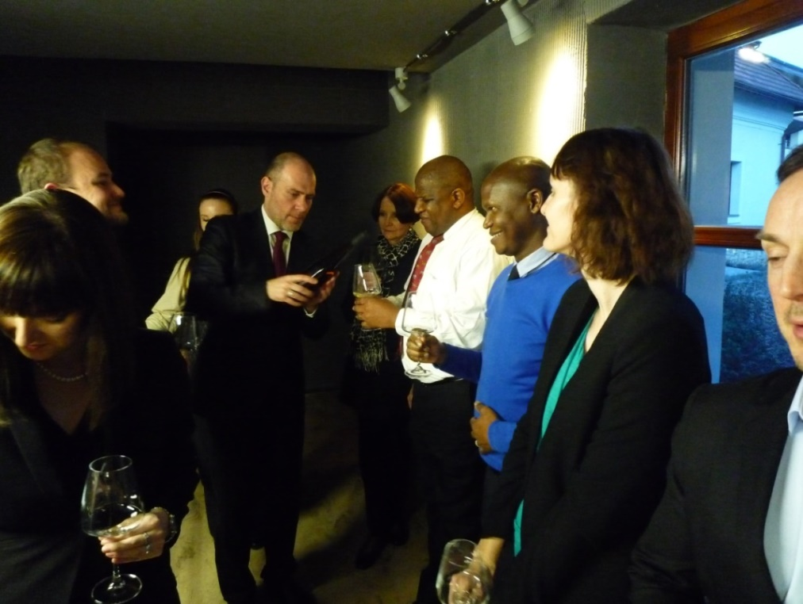

*The Ambassador, Mr Dasa and Mr Ncongwane*

*at the wine tasting*

***Across Africa in a Month***

On 26 February 2016, the Ambassador attended the 3rd session of the *Around Africa in a Month* series of monthly meetings organized by the NGO Humanitas Afrika. Since February is Black History Month (America), the meeting took place in co-operation with the US Embassy and the American Center Prague.

 

Dr Hana Horáková, President of the Czech Association for African Studies gave a lecture on *The Relevance and Impact of Nelson Mandela in a UN decade for African Descent.*

***Meeting with director of Jihlava Zoo***

On 25 February 2016 the Ambassador met Ing Eliška Kubíková, Director of the Jihlava Zoo to discuss possible co-operation.

n oN

***Diplomatic functions***

In the month of February, the Ambassador attended a reception on the occasion of the Chinese New Year; National Day celebrations of Kuwait and Iran; a working breakfast with the CEO of MAVEL company; a working lunch hosted by the Ambassador of Morocco and a Francophone lunch hosted by the Ambassador of France where the Minister of Justice Pelikán was the guest of honour.

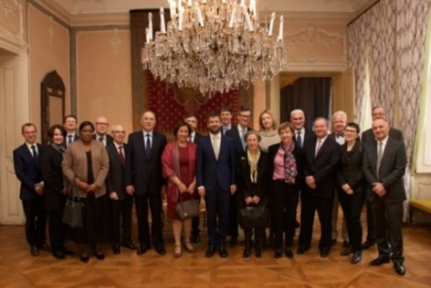

*Participants at the Francophone lunch, French Embassy in Prague, Velkopřevorské nám. 4 February 2016. Picture: Embassy of France*

New Ambassador of India paid a courtesy call on 22 February 2016.

**STAFF NEWS/SA CITIZENS**

***Visit of Mr Molapo***

Retired South African diplomat Mr Seemane Abia Molapo visited the Embassy on 19 February 2016. He worked as First Secretary at the Embassy from 2001 to 2006.

**SOUTH AFRICAN NEWS**

# *State of the Nation Address 2016*

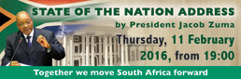

President Jacob Zuma presented the State of the Nation Address (SoNA) to a joint sitting of the two Houses of Parliament (National Assembly and National Council of Provinces) on 11 February 2016. The 2016 theme was: *Following up on our commitments to the people.*

During his speech, the President talked about government’s achievements of the past year and looked to the future by presenting a programme for the coming year.

**Key points raised during the State of the Nation:**

* *Elections*
* *Healthcare*
* *Police*
* *Land Ownership*
* *Drought Relief*
* *Economic Crisis*
* *Nuclear Power*
* *Government Cost Cutting*
* *Two Capitals*
* *Migration Policy*

*(For more details and SoNA in numbers please see the enclosure).*

***SA-EU Ministerial Meeting***

[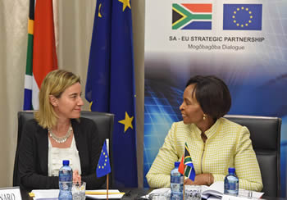](http://www.dfa.gov.za/images/gallery8/mashabane_eu_mogherini2.jpg)

*Minister Maite Nkoana-Mashabane with her counterpart, Ms Federica Mogherini during Bilateral Discussions, Pretoria, South Africa, 26 February 2016. Picture: Jacoline Schoonees*

The 13th South Africa–European Union Ministerial Political Dialogue Meeting was held on 26 February 2016. The EU as a bloc is South Africa’s largest trading partner and largest foreign investor with over 2000 EU companies operating in South Africa, creating over 350 000 jobs.

***Annual Ubuntu Awards***

[](http://my-event.co/ubuntuawards16/)International Relations and Cooperation Minister Maite Nkoana-Mashabane hosted the annual Ubuntu Awards at the Cape Town International Convention Centre on 13 February 2016.

#### Winners

* ***Ubuntu Economic Diplomacy Award:*** Standard Bank (Africa) and Discovery (Global)
* ***Ubuntu Arts and Cultural Diplomacy Award:*** DJ Black Coffee and musician Hugh Masekela
* ***Ubuntu Social Responsibility Award:*** Rescue SA and the Motsepe Foundation
* ***Ubuntu Sport Diplomacy Award:*** Runner Wayde van Niekerk
* ***Ubuntu Youth Diplomacy Award:*** Former Miss Earth, LeadSA executive and Play your Part ambassador Catherine Constantinides
* ***OR Tambo Lifetime Achievement Award (Minister’s Award):*** Agnes Msimang and the late Johnny Makhathini for their contribution to the anti-apartheid struggle
* ***Ubuntu Ambassadorial Excellence Award:*** Bene L M'Poko, DRC Ambassador to South Africa

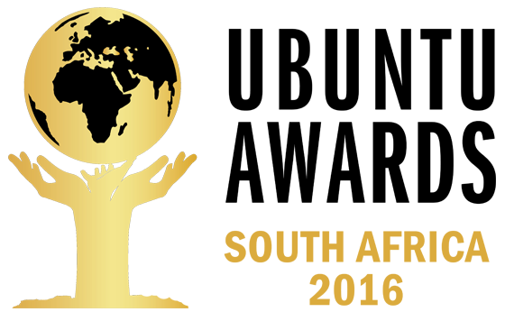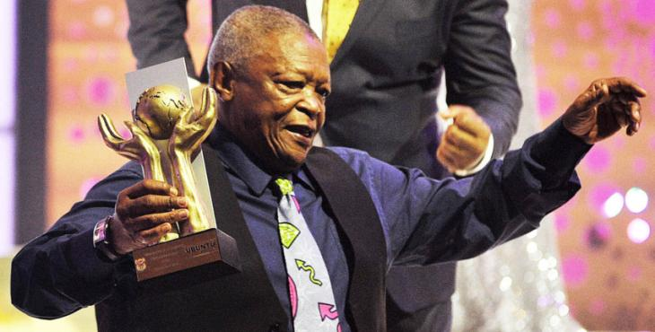

*Hugh Masekela receives the Cultural Diplomacy award at the Ubuntu Awards in Cape Town.*

*Picture: Bheki Radebe/Cape Argus*

***Krejčíř sentenced to 35 years***

Czech fugitive Radovan Krejčíř was sentenced by a South African court to 35 years’ imprisonment for kidnapping, attempted murder and drug dealing on 23 February 2016. Krejčíř faces three other serious charges in the RSA.

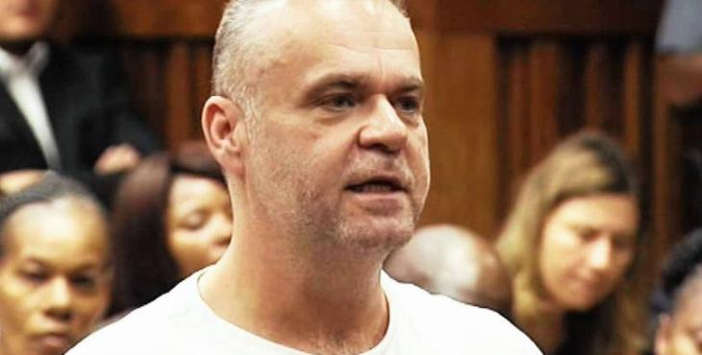*Picture: ENCA*

**CZECH NEWS**

***Minister Zaorálek visited Middle East***

Czech Minister of Foreign Affairs Lubomír Zaorálek, accompanied by a business delegation from more than 20 Czech firms, visited the Arab Republic of Egypt from 30 January to 1 February 2016. Minister Zaorálek met top representatives of Egypt; he opened a business forum and visited the Czech Institute of Egyptology excavation plot south of Giza. On 2 February 2016 the delegation visited Oman. It was the first official visit of Czech Foreign Minister to that country.

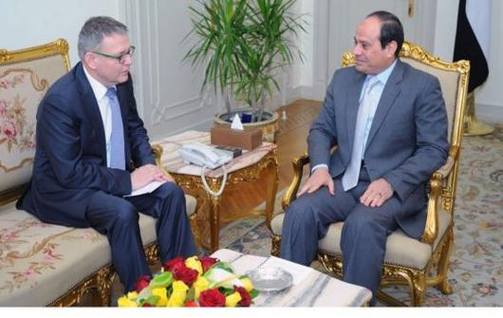

*Minister Lubomír Zaorálek and President Abd Al Fattah Al Sisi, Heliopolis, EAR. Picture: MFA*

***Extraordinary V4 Summit on migration***

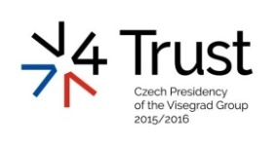On 15 February 2016 an Extraordinary Summit of the Visegrad Group Countries took place in Prague. Prime Ministers of the Czech Republic, Slovakia, Poland and Hungary, as well as President of Macedonia and Prime Minister of Bulgaria discussed ways of bringing the influx of migrants under control.

The first joint meeting of the tripartites (state, employers and workers) of the Visegrad Group Countries was held on 16 February 2016.

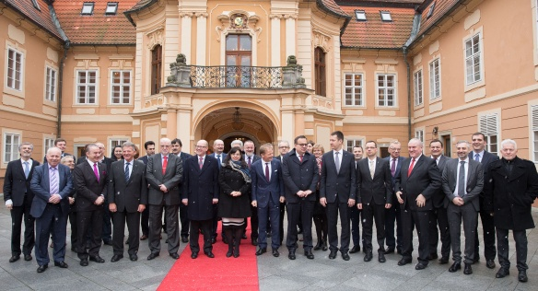*Picture: MFA/ M. Novotný*

The meeting of the V4 Foreign Ministers was held on 18 February 2015 to evaluate cooperation among the Visegrad partners and discuss EU and foreign policy issues. A meeting of the V4 Think Tank Platform *Think Visegrad* was held on the same day.

***Czech designer and architect Bořek Šípek dies***

[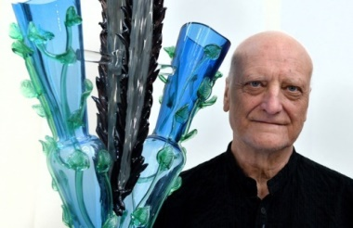](http://www.ceskenoviny.cz/news/index_img.php?id=366684)Renowned Czech designer and architect Bořek Šípek died of pancreas cancer on 13 February 2016, aged 66. Šípek emigrated from communist Czechoslovakia and studied architecture in Germany before establishing studio in the Netherlands. He became chief architect at the Prague Castle after the Velvet Revolution. He created chandeliers, glass art pieces, furniture and some new entrances.

***Czech artist Zdenek Smetana dies***

[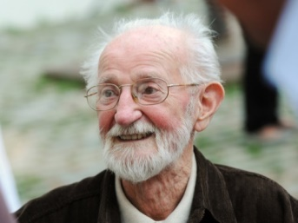](http://www.ceskenoviny.cz/news/index_img.php?id=367922)Czech artist and animator Zdenek Smetana, author of popular TV bedtime stories died on 25 February 2016 at the age of 90.

|  |
| --- |
| For more information about the activities of the South African Embassy in Prague please visit our website:  http://[www.saprague.cz](http://www.saprague.cz) |

*Enclosure No. 1*

***State of the Nation Address (SoNA)*** – February 2016

President Jacob Zuma highlighted a few areas government needed to work on in 2016:

1. **Elections**

L**ocal government** elections will be held this year. President urged the youth to register to vote.

1. **Healthcare**

President Zuma announced the establishment of a **state-owned pharmaceutical company** which would supply the Department of Health with antiretrovirals in the 2016/17 financial year.

1. **Police**

Fifty-seven **police officers** had been killed since the start of the 2015/16 financial year. President urged the police to defend themselves when attacked, within the confines of the law. Efforts were being made to improve under-performing police stations.

1. **Land Ownership**

A draft bill capping land ownership at 12 000 hectares and prohibiting foreigners from owning land, allowing long-term leases instead, will be presented to Parliament.

1. **Drought Relief**

Five provinces have been seriously affected by the **drought**and government was providing relief to affected communities. President thanked civil society initiatives such as Operation Hydrate for their help.

1. **Economic Crisis**

President Zuma attributed the country's **economic woes** to the economic slump that other emerging market economies elsewhere in the world are facing.

**7)** **Nuclear Power**

The country would roll out a **nuclear** programme at a pace South Africa could afford.

**8)** **Government Cost Cutting**

Government will introduce cost-cutting measures to curb **wasteful expenditure**. Any government official wanting to go on an overseas trips would have to "motivate strongly" and explain how it would benefit the country. Trip delegations will be reduced and standardised.

**9)** **Two Capitals**

Parliament was asked to consider the feasibility of continuing system of two capitals (Pretoria as administrative and Cape Town as legislative).

**10)** **Migration Policy**

An improved **migration policy** would make it easier for companies to import scarce skills.

***SoNA in Numbers***

*Economy*

* **R100 million** – to be invested a year by South African Tourism to promote domestic tourism.
* **10th** – South Africa’s ranking in the World Economic Forum competitiveness report.
* **US$50 billion** – investments announced by China.
* **US$10 billion** – investment from China to South Africa for infrastructure, industrialisation and skills development.
* **5%** – the annual growth target set in the National Development Plan to be achieved by 2019.
* **R25 billion** – investments attracted by incentives for the automotive sector over the last five years.

*Energy*

* **R83 billion** – government’s investment in Eskom.
* **R194 billion** – an investment attracted by the Renewable Independent Power Producer Programme.
* **9 600** – megawatts of energy to be introduced in the next decade.

*Agriculture and land reform*

* **5** – the number of Agri-parks being constructed.
* **27** – the number of proposals received from commercial farmers.
* **4** – the number of proposals received from commercial farmers that are being implemented in the Eastern Cape and the Free State.
* **12 000** – the maximum hectares to be allowed for land ownership.
* **120 000** – the number of new land claims lodged by December 2015.

*Water and sanitation*

* **30** **million** - cubic meters of water to be provided per year by the Mokolo and Crocodile Water Augmentation project in Lephalale, Limpopo.
* **13 -** the raised metres of the Clan William Dam wall in the Western Cape.
* **15 000** – number of young people being trained by the Department of Water and Sanitation to curb water wastage.

*Oceans economy*

* **R7 billion** – money committed in new port facilities by the Transnet National Ports Authority.
* **3 000** – kilometres of coastline surrounding South Africa.
* **R660 million** – investment brought by a fuel storage facility in Cape Town.
* **R350 000** – investment being committed in the aquaculture sector.
* **9** – aquaculture farms already in production in the Eastern Cape, KwaZulu-Natal, Western Cape and Northern Cape.

*Broadband roll-out*

* **5 000** – government facilities in eight district municipalities to benefit from broadband roll-out.
* **R740 million** – funding for a broadband roll-out allocated over a three-year period to connect more than 5 000 government facilities in eight district municipalities.

*Health*

* **62** – life expectancy for both male and female South Africans, which is an increase of 8.5 years since 2015.
* **3.2 million** – HIV-positive people who benefitted from a massive roll-out of HIV testing and treatment in 2009.

*Safety and security*

* **57** – the number of police officers murdered to date during the 2015/16 financial year.

*Employment*

* **2 000** – number of European Union companies operating in South Africa.
* **350 000** – number of jobs created by the European Union.