|  |
| --- |
| [Click on the specific symbol to view its symbolism  [coatofarms.gif 22315 bytes)](http://www.gov.za/_vti_bin/shtml.dll/symbols/coatofarms.htm/map) |
|  |

**EMBASSY OF SOUTH AFRICA  
RUSKA 65, 100 00 PRAGUE 10**

**NEWSLETTER 4 - APRIL 2016 (No.4)**

[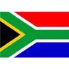](http://www.google.co.za/imgres?imgurl=http://sasportswear.co.za/images/sportswear/south_african_storm_flag.jpg&imgrefurl=http://sasportswear.co.za/sa-memorabilia-7/sports-flags-21/south-african-flag-storm-72.html&h=591&w=591&sz=35&tbnid=Uv7cCdEcYE0-pM:&tbnh=135&tbnw=135&prev=/images?q=South+African+flag&hl=en&usg=__g8gihHXhaZlPhuEToAfXga4s4Hw=&sa=X&ei=IslOTK-nNo-R4Qay7dWoCA&ved=0CAgQ9QEwAQ)



**WORD BY THE AMBASSADOR**

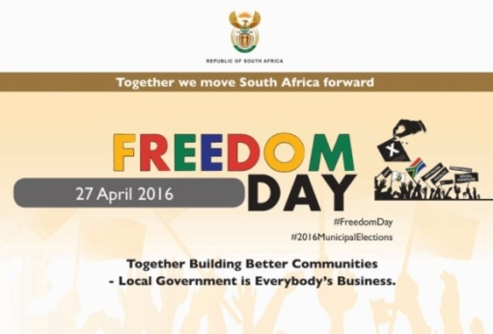

April was a very busy month for us at the Embassy but filled with interesting events, most importantly the celebration of Freedom Day. It was a proud and happy moment for us to share this day with the people of the Czech Republic and to celebrate with South Africans currently living here. It was also a moment to reconnect with people with whom we have made contact over the years and to express our appreciation for their continued cooperation and assistance.

The Embassy also had the pleasure of teaming up with the Czech Rugby Union for the visit of an U-19 rugby team from Pecanwood College in South Africa. While rugby is not a sport one would normally associate with the Czech Republic, it has grown considerably in popularity in recent years and there was great excitement among the Czech team to be playing for the first time against a team from a serious rugby country. However, the most important point was not the match or the result, although I was very proud that the South African boys won, but the opportunity for the young people to learn more about each other’s countries. The South African team visited a few schools and talked about South Africa’s diversity. They even gave impromptu performances of traditional dances from different parts of the country. The feedback from Czech side was very positive and it is hoped that a Czech team would be able to travel to South Africa next year to continue the interaction.

On a more serious note, it was a great honour to be invited together with the other Ambassadors of Sub-Saharan countries to meet Prime Minister Sobotka and to talk about opportunities and challenges in Africa.

**EMBASSY NEWS**

***Lunch of African Ambassadors with Czech Prime Minister Bohuslav Sobotka***

Czech Prime Minister Bohuslav Sobotka hosted a working lunch for the Ambassadors of Sub-Saharan Africa in the Lichtenstein Palace on 21 April 2016. Ambassador Verwey, being the Dean of the Sub-Saharan group, gave an address on behalf of the group.

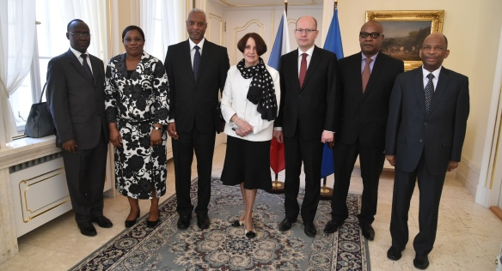

*Picture: PM’s Office*

Topics under discussion included relations with the Czech Republic, development cooperation, mutual trade; challenges of Sub-Saharan countries like the security situation and migration.

***National Day celebration***

The Embassy celebrated Freedom Day at the Hilton Hotel on 29 April 2016. More than 200 people attended the reception, including around eighty Ambassadors, South Africans resident in the Czech Republic and nearly twenty South African students currently studying in the country. Deputy Minister Martin Tlapa responded to Ambassador Verwey’s Freedom Day message on behalf of the Czech Foreign Ministry. The atmosphere at the function was very festive and the guests clearly enjoyed themselves.

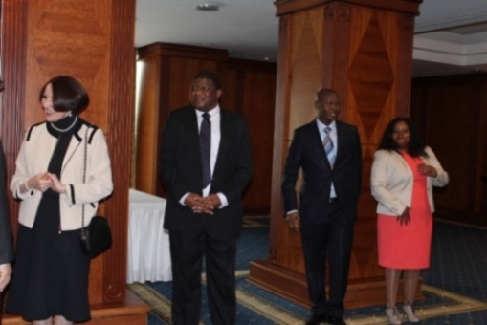

*Ambassador Verwey, Mr Dasa, Mr Ncongwane and Ms Radebe-Mothibe welcome the guests*

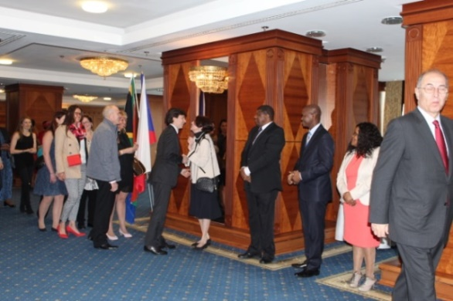

*People queue to greet Ambassador and other diplomats. Ambassador Verwey shakes hands with American Ambassador Mr Andrew Schapiro.*

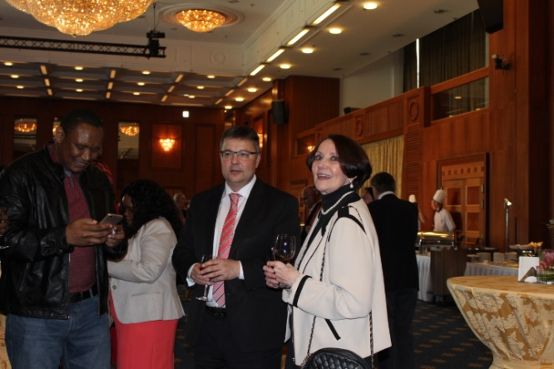 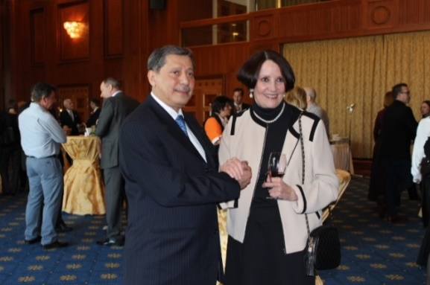

*Deputy Minister Martin Tlapa (left picture) and Ambassador of Yemen Mr Abdulrahman Mohamed Al-Hamdi (right) with Ambassador Verwey*

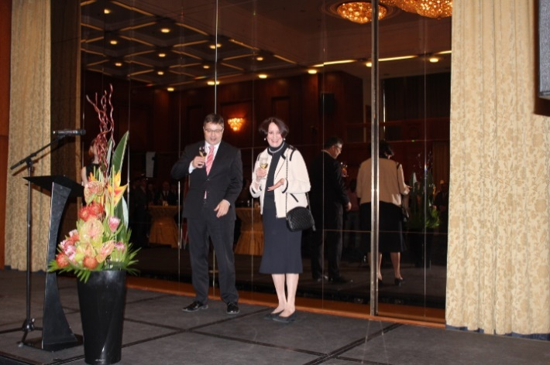

*Ambassador Verwey and Deputy Minister Martin Tlapa raise glasses to toast continued Czech-South African friendship*

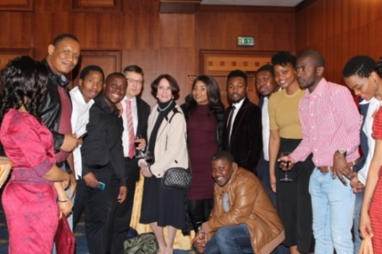

*Ambassador Verwey and Deputy Minister Martin Tlapa among South African students*

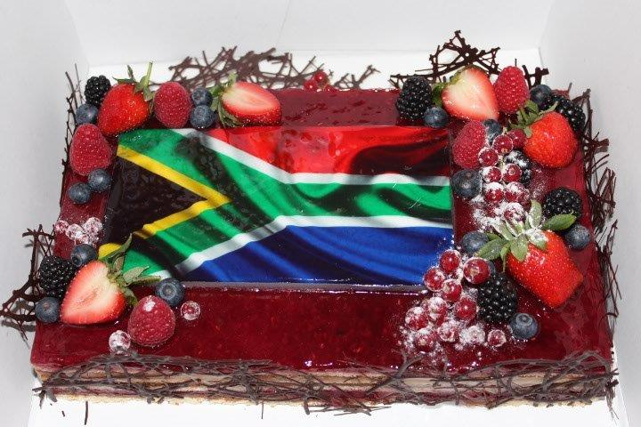

*A cake offered by the Hilton Hotel*

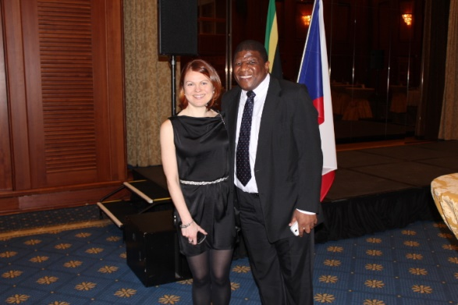 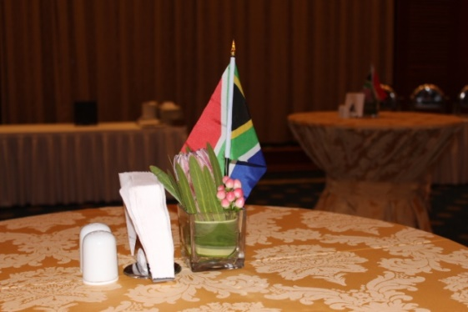

*Ms Hlávková and Mr Dasa Protea decoration*

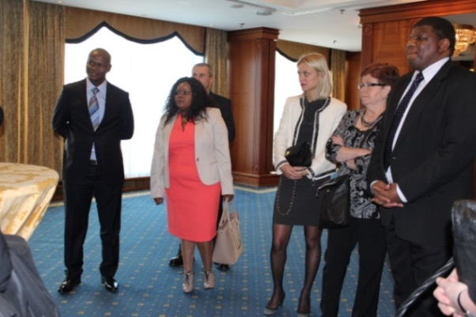

*Mr Ncongwane, Ms Radebe-Mothibe, Ms Stifter,*

*Ms Nalevajková, Ms Dastychová and Mr Dasa*

***Meeting of African Heads of Mission***

The Ambassador attended a meeting of African Heads of Mission hosted by the Ambassador of Morocco on 7 April 2016 to discuss joint events to be held this year in celebration of Africa Day.

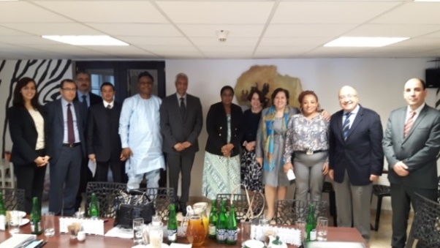

*Picture: Embassy of Morocco*

***Diplomatic Breakfast dedicated to Africa***

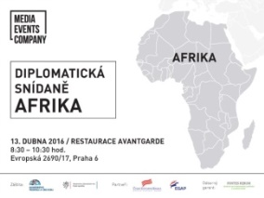On 13 April 2016, the Ambassador participated in a Diplomatic Breakfast focused on doing business in Africa. Ambassador gave a presentation on business opportunities in South Africa with emphasis on the green economy.

***Conference Overcoming Global Threats***

[](http://www.cas.cz/index.html)On 13-14 April 2016, Ambassador attended the conference on *Overcoming Global Threats*: *Enhancing Inter-cultural Dialogue, Stability and Peace* which was organized by the Czech Academy of Sciences in cooperation with the Ministry of Foreign Affairs and the Ambassadors of Organization for Islamic Cooperation countries represented in Prague.

z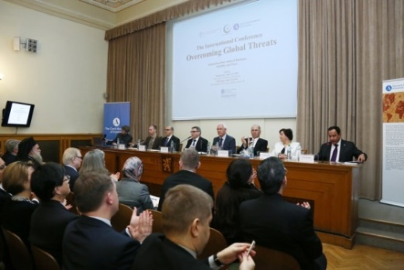

*Photo: Stanislava Kyselová (Academic bulletin*)

Main addresses were given by Minister of Foreign Affairs Mr Lubomír Zaorálek, President of Czech Academy of Sciences Mr Jiří Drahoš and the Ambassadors of Turkey and Morocco. Discussions focused on the vital importance of inter-cultural dialogue as a means of promoting local and global justice, stability and peace, overcoming global conflicts and developing religious tolerance and mutual cooperation.

***Across Africa in a month***

The Ambassador attended the 4th session of the monthly event *Across Africa in a Month* held by the Humanitas Afrika NGO on 1 April 2016 with the topic *The Challenges of Climate Change and Sustainable Development.*

[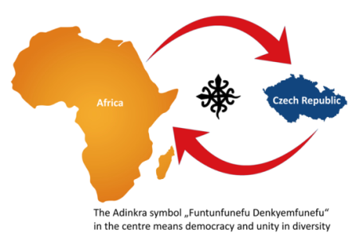](https://www.facebook.com/africke.informacni.centrum/photos/gm.996763010406539/955638874489350/?type=3)

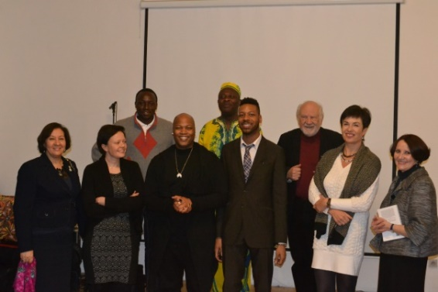

*Ambassador Verwey (left ) with participants at the*

*Across Africa in a Month event.*

*Picture: Humanitas Afrika*

***South African Rugby team in Prague***

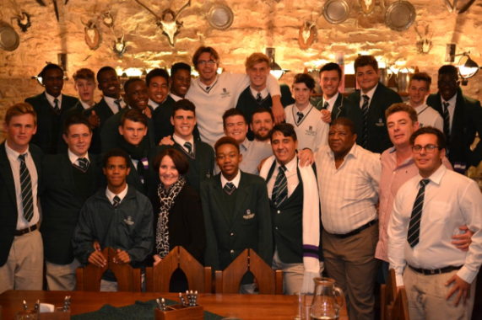

*Ambassador Verwey and Mr Dasa with the Pecanwood rugby team during a dinner hosted by the Embassy, 18 April 2016.*

[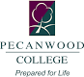](http://www.pecanwoodcollege.co.za/wp-content/uploads/2014/03/PWC-Logo.png)An Under-19 rugby team from Pecanwood College in South Africa stopped over in the Czech Republic during their tour of several countries in Europe in April.

They played a match against a team from the Tatra Smíchov Club in Prague on 17 April 2016.

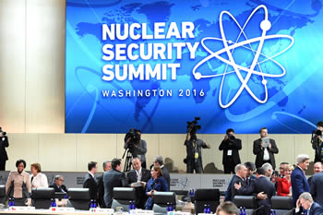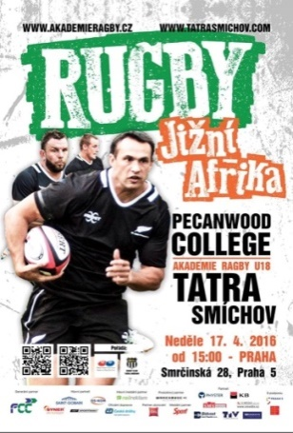 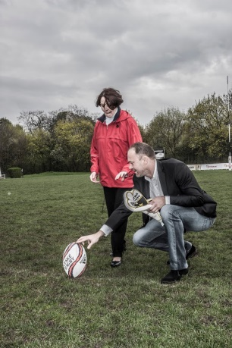

*The Ambassador preparing to do the kick-off in the match Pecanwood College versus Tatra Smíchov.*

***Diplomatic cup***

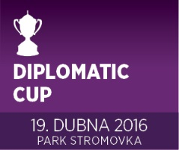The Czech Ministry of Foreign Affairs and various embassies and international organisations took part in the Diplomatic Cup, a special category of the Prague Relay Race 4x5km which was held in Prague – Stromovka on 19 April 2016. The South African Embassy team, represented by Ms Michaela Hlávková and Mr Nicholas Wood finished the fourth. Congratulations!

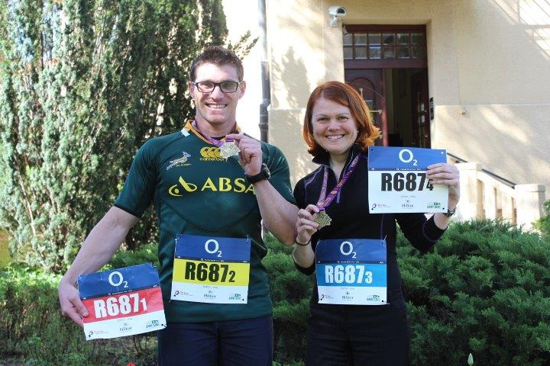

*Mr Nicholas Wood and Ms Michaela Hlávková*

***Diplomatic Functions***

The Ambassador attended a working lunch hosted by the Ambassador of Brazil where political analyst Mr Jiří Pehe was the guest of honour; a dinner hosted by Ambassador of India; a dinner with Prof Saths Cooper from South Africa, President of the International Union in Psychological Science; a lunch of women Ambassadors with women members of the Board of the Czech Academy of Sciences; Ellenbogen Citizenship Award ceremony hosted by the Prague Society; a dinner with conductor Pietari Inkenen as guest of honour hosted by Ambassador of Finland; a concert by Moroccan pianist; and a meeting of Minister of Industry and Trade Jan Mládek with Diplomatic Corps.

The Ambassadors of Argentina and Peru paid courtesy calls on Ambassador Verwey.

**SOUTH AFRICAN NEWS**

***Nuclear Security Summit***

The South African delegation led by International Relations and Cooperation Minister Ms Maite Nkoana-Mashabane attended the 2016 Nuclear Security Summit in Washington D.C. from 31 March to 1 April 2016. Nuclear security threat perceptions, national actions to enhance nuclear security as well as international and institutional actions to strengthen nuclear security were discussed.

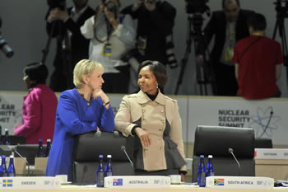

*Minister Maite Nkoana-Mashabane at the opening of the 2016 Nuclear Security Summit .*

*Picture: Yolande Snyman*

***SA-Malawi Joint Commission of Cooperation***

Deputy Minister Luwellyn Landers co-chaired a session of the South Africa - Malawi Joint Commission of Cooperation hosted by the Republic of Malawi from 6-7 April 2016.

***Imbizo Focus Week***

The 4th National Imbizo Focus Week was held from 4 to 10 April 2016 to enable members of the administration from all three spheres of government to interact with communities and individuals about pronouncements made by President Jacob Zuma during the State of the Nation Address.



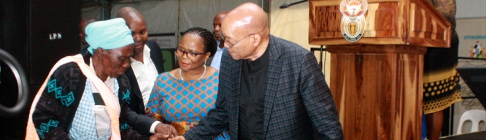

*President Zuma visits the area to monitor the delivery of water services and to launch a drought relief programme. Picture: The Presidency*

***President Zuma visited Iran***

President Zuma undertook a State Visit to Iran from 24-25 April to meet his counterpart President Rouhani and other top representatives of the country. Eight Memoranda of Understanding were signed during the visit.

***President Zuma bestowed National Orders Awards***

On 28 April 2016, President Jacob Zuma bestowed National Orders Awards on 32 distinguished people, some of them in memoriam, who played a significant role in building a free democratic South Africa and improving the lives of South Africans.

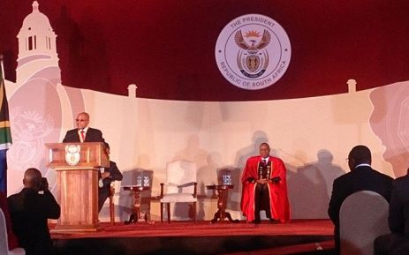

*President Jacob Zuma at the National Order Award ceremony in Pretoria on 28 April 2016.*

*Picture: The Presidency*

The honours included the Order of Mendi for Bravery, the Order of Ikhamanga, the Order of the Baobab, the Order of Luthuli and the Order of the Companions of OR Tambo. Former presidential spokesman Mac Maharaj and struggle stalwart Winnie Madikizela-Mandela were among the recipients.

***DIRCO won UNIVERSUM Most Attractive Employers Award***

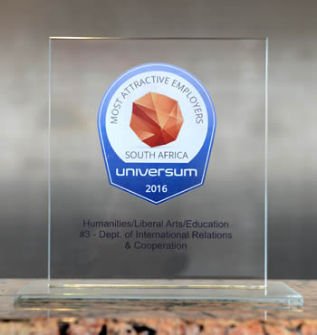The Department of International Relations and Cooperation (DIRCO) achieved 3rd place in the recent UNIVERSUM Most Attractive Employers Awards for the category: *Humanities/Liberal/Arts/Education*.

DIRCO is perceived by other professionals as a desired place to work due to aspects like international exposure, training opportunities and travelling.

***Archbishop Tutu received award***

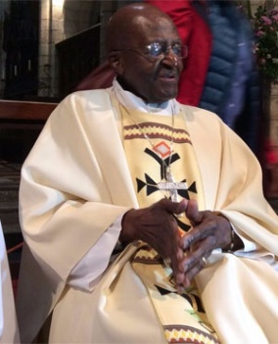Archbishop Desmond Tutu and his wife Leah received the Award for Peace with Justice at the Saint George’s Cathedral in Cape Town on 22 April 2016.

**CZECH NEWS**

***Austrian President in Czech Republic***

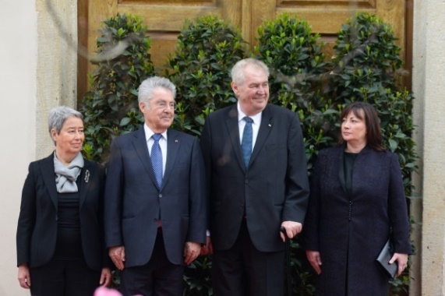

*Presidents Heinz Fischer(left) and Miloš Zeman with their wives. Picture: Prague Castle*

Austrian President Heinz Fischer arrived in the Czech Republic on a two-day visit from 11-12 April 2016. He had discussions with Czech President Miloš Zeman, Prime Minister Bohuslav Sobotka and other leaders of the country. He also laid a wreath at the grave of Czechoslovakia’s first president Tomáš Garrigue Masaryk at Lány cemetery.

[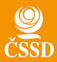](http://cssd.cust.nlogy.cz/img/cssd-logo.jpg)

***PM Sobotka visited USA***

Prime Minister Bohuslav Sobotka visited the USA from 31 March to 4 April 2016. He participated in the Nuclear Security Summit held in Washington DC.

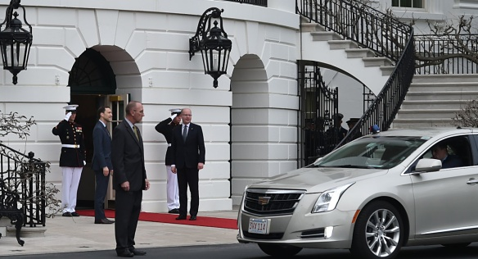

*On Thursday 31 March 2016, Czech Prime Minister Bohuslav Sobotka attended a gala evening hosted at the White House by President Barack Obama.*

*Picture: Czech Embassy in Washington DC*

Prime Minister Bohuslav Sobotka also met representatives of major US corporations in Washington; the Governor, filmmakers and SpaceX management in California; and Czech compatriots in Washington DC, Minneapolis, Los Angeles and San Francisco. The USA is home to the world’s largest Czech community outside the Czech Republic numbering some 1.7 million people.

***PM Bohuslav Sobotka*** ***visited Afghanistan***

Prime Minister Bohuslav Sobotka and Chief of Staff Josef Bečvář visited Afghanistan from 24-25 April 2016 to meet government representatives and Czech soldiers at the Bagram and Kabul bases.

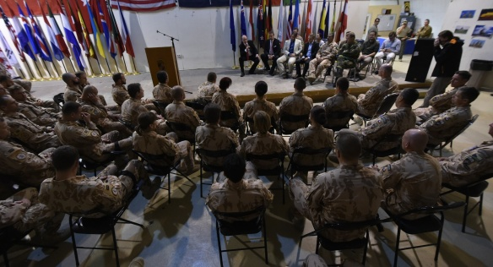

*Picture: Prime Minister’s Office*

About 245 Czech soldiers operate in the NATO mission in Afghanistan.

***ČSSD ordered to pay 340 million crowns***

The ruling Czech Social Democratic Party (ČSSD) was ordered by the court to pay its former lawyer Zdenek Altner a debt of 18.5 million crowns plus more than 300 million crowns as a contractual fine. In 1997 Altner helped ČSSD to get back Lidový dům, the party’s seat in Prague for which he wanted 10% of the value of the building. The ČSSD appealed to the Supreme Court and Altner filed a distraint petition against the ČSSD.

***Completion of Translations of the Short name Česko/Czechia***

The Ministry of Foreign Affairs of the Czech Republic (MFA) suggests that English-speakers should start using the name of *Czechia* as the short version of the country name. The official name of the country will remain *Czech Republic*.

In some languages, the Czech Republic’s short name is already well established e.g. in French – la Tchéquie, Spanish – Chequia, German – Tschechien. The MFA will request the United Nations to enter short name of the country, i.e. *Czechia* in the UN country name databases.

CZECH REPUBLIC X CZECHIA

[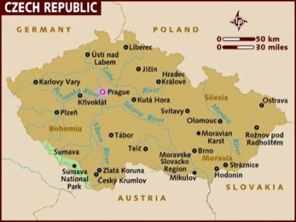](http://www.lonelyplanet.com/destinationRedirector?openMap=true&ethylCobjId=794)

|  |
| --- |
| For more information about the activities of the South African Embassy in Prague please visit our website:  http://[www.saprague.cz](http://www.saprague.cz) |