|  |
| --- |
| [Click on the specific symbol to view its symbolism  [coatofarms.gif 22315 bytes)](http://www.gov.za/_vti_bin/shtml.dll/symbols/coatofarms.htm/map) |
|  |

**EMBASSY OF SOUTH AFRICA  
RUSKA 65, 100 00 PRAGUE 10**

**NEWSLETTER - OCTOBER 2016 (No.10 )**

[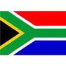](http://www.google.co.za/imgres?imgurl=http://sasportswear.co.za/images/sportswear/south_african_storm_flag.jpg&imgrefurl=http://sasportswear.co.za/sa-memorabilia-7/sports-flags-21/south-african-flag-storm-72.html&h=591&w=591&sz=35&tbnid=Uv7cCdEcYE0-pM:&tbnh=135&tbnw=135&prev=/images?q=South+African+flag&hl=en&usg=__g8gihHXhaZlPhuEToAfXga4s4Hw=&sa=X&ei=IslOTK-nNo-R4Qay7dWoCA&ved=0CAgQ9QEwAQ)



**WORD BY THE AMBASSADOR**

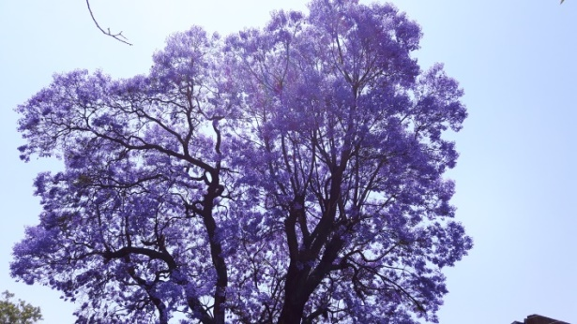

October was packed with events. I was deeply honoured to attend the special concert at the beautiful Rudolfinum Theatre to commemorate the 80th birthday of the late much revered President Václav Havel.

I also had an opportunity this month to travel to South Africa to attend the Heads of Mission Conference. It was a great joy for me to be in Pretoria at the time when the jacarandas were in full bloom and to touch base with Head Office. By lucky coincidence, I was also able to attend the Independence Day celebration hosted by Czech Ambassador to South Africa, Mr Michal Král at the Czech Residence in Pretoria. The reception was held at midday and guests enjoyed national delicacies in the garden of the residence under the hot African sun. On my return to Prague, I attended the official National Day celebrations hosted by President Zeman at Prague Castle, certainly a contrast to the garden reception in South Africa. As always, I was in awe of the surroundings at the Castle, particularly the exquisite Gothic Vladislav Hall where the awards ceremony took place.

**EMBASSY NEWS**

***HOM Conference***

The Ambassador attended the biennial South African Heads of Mission Conference hosted at DIRCO in Pretoria from 17-21 October 2016. The Conference brought together South African Heads of Mission from all over the world to assess national, regional, continental and global trends and dynamics. It also determined a strategy to be implemented in line with South Africa’s foreign policy.

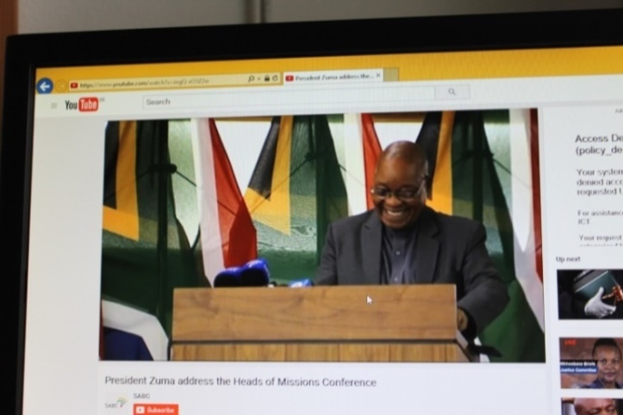

*President Zuma addressing the Heads of Mission Conference, Pretoria, 18 Oct 2016. Picture: SABC*

In his keynote address, President Jacob Zuma briefed the diplomats about progress on government programmes and plans.

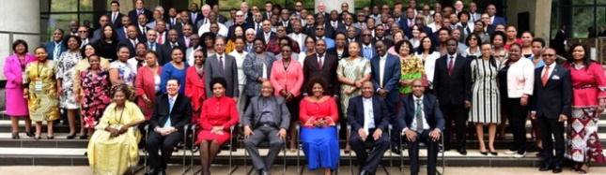

*President Jacob Zuma with the South African Heads of Mission during the Heads of Mission Conference in Pretoria. Picture: The Presidency*

***Diplomatic events celebrating Czech Republic National Day***

On 24 October 2016, the Ambassador attended a reception hosted by the Czech Embassy in Pretoria on the occasion of the forthcoming National Day of the Czech Republic. The reception was graced by presence of the South African Minister of Home Affairs.

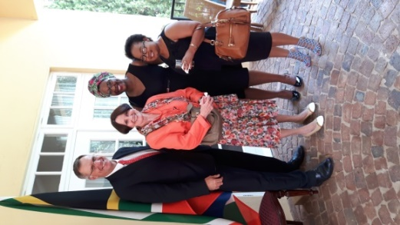

*Ambassador Verwey*

*with Head Office colleagues*

*Johan Oberholzer,*

*Thando Hlatswayo and*

*Alinah Mailula at the*

*Czech National Day celebration in Pretoria,*

*24 October 2016.*

In Prague, the Ambassador attended a meeting of Diplomatic Corps with President Miloš Zeman on 27 October 2016 and the presentation of National Decorations of the Czech Republic in the Vladislav Hall of Prague Castle on 28 October 2016.

*(See page 6 – National Day celebration).*

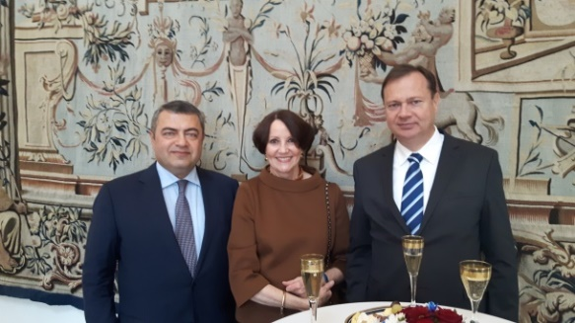

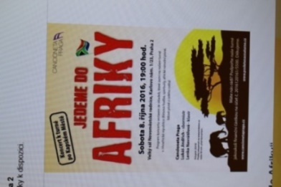*Ambassador Verwey with Ambassadors of Armenia and Hungary at the reception following the President’s meeting with the Diplomatic Corps, 27 Oct 2016*

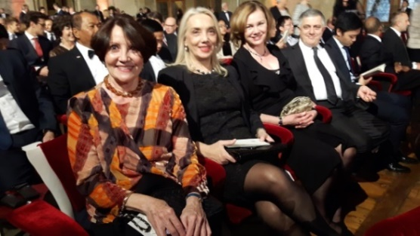

*Ambassador Verwey and other members of the Diplomatic Corps at Prague Castle, 28 Oct 2016*

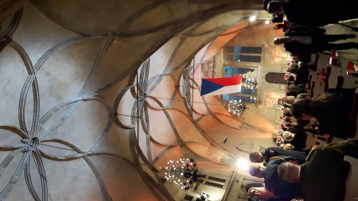

*Vladislav Hall,*

*Prague Castle,*

*28 October 2016*

***Prague Writers Festival***

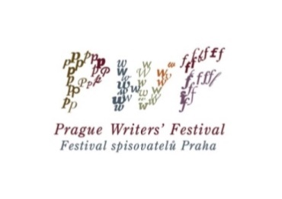Ambassador attended the festive opening of the Prague Writers Festival on 7 October 2016. The Festival, bringing together well-known authors from all over the globe, was held under the theme *Crime and Punishment as a Mirror of Society*.

[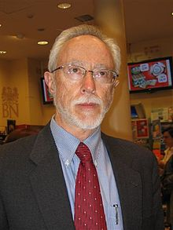](https://en.wikipedia.org/wiki/File:J.M._Coetzee.JPG)John Maxwell Coetzee, a South African novelist, linguist, translator and 2003 Nobel Laureate for Literature presented his new novel at the festival on 18 October 2016.

***Pain is truth — all else is subject to doubt.***

Coetzee

***Going to Africa concert***

Cancioneta Praga girls choir has for some time been preparing for their visit to South Africa in October 2016 at the invitation of the Cape Town Youth Choir (CTYC). On the eve of their departure, they gave a performance at the 14th century New Town Hall (Novoměstská radnice). Their repertoire included spirituals, African songs and folk songs from all over the world.

From Embassy side, Ambassador, Ms Hosking and Mr Ncongwane attended the enjoyable concert called *Going to Africa* *(Jedeme do Afriky).*

***Diplomatic events***

The Ambassador attended National Day receptions of Germany, Indonesia and Turkey; Armed Forces Day of Egypt; farewell receptions hosted by the aaaaaaaaaaaaaaaaaaaaaaaaaaaaaaaaaaaaaaaaaaaaaaaaaaaaaaaaaaaaaaaaaaaaaaaaaaaaaaaaaaAmbassadors of Mongolia and Bosnia&Hercegovina; and an exhibition at Strahov monastery hosted by the Belarussian Ambassador.

The Ambassador also attended a concert organized to commemorate President Václav Havel’s 80th birthday (see page 5).

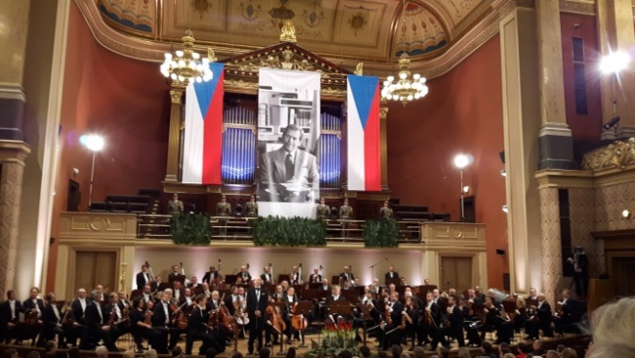

*Concert in Rudolfinum, Prague, 5 October 2016*

**SOUTH AFRICAN NEWS**

***BRICS Summit in India***

President Zuma led the South African delegation to the 8th  BRICS Summit (Brazil, Russia, India, China, South Africa) in India from 15-16 October 2016.

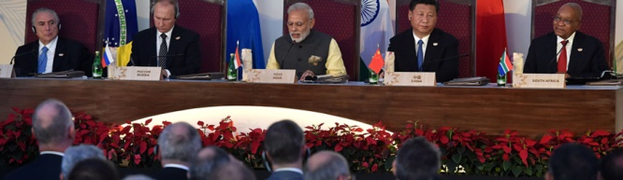*BRICS leaders pose for pre-dinner pictures ahead of the 8th BRICS Summit in India. President Jacob Zuma and other BRICS leaders during a BRICS Business Council meeting on the sidelines of the BRICS Summit, India.  Picture: The Presidency*

**State Visit to Kenya**

President Jacob Zuma paid a State visit to Kenya from 10-12 October 2016 to discuss trade, security and immigration with the Kenyan President Uhuru Kenyatta.

[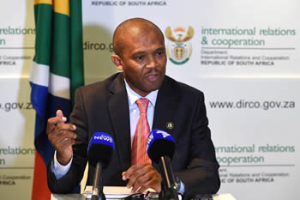](http://www.dirco.gov.za/images/gallery8/seokolo_media-brief1019_1.jpg)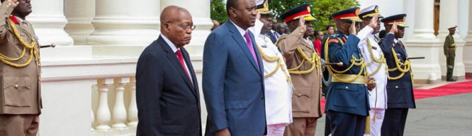

*President Jacob Zuma observing a Guard of Honour during his Welcome Ceremony in Kenya. Picture: The Presidency*

***RSA-Namibia Bi-National Commission***

**The RSA hosted the 2nd South Africa-Namibia Bi-National Commission in Pretoria from 6 -7 October 2016.**

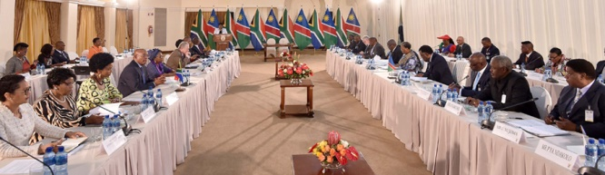

*President Jacob Zuma and President Hage Geingob of Namibia during the South Africa-Namibia Bi-National Commission, Pretoria , 7 October 2016. Picture: The Presidency*

***Working visit to Vietnam and Singapore***

**Deputy President Cyril Ramaphosa paid a two-nation visit to the Socialist Republic of Vietnam and to Singapore from 03-07 October 2016.**

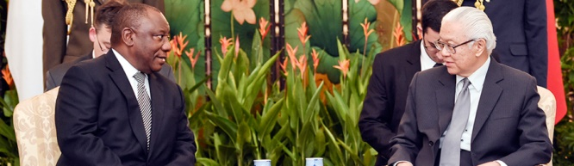

*Deputy President Cyril Ramaphosa paying a courtesy call on President Tony Tan Keng Yam of Singapore, Singapore*

Among other topics, the sale of South African mining and defence products to Vietnam, as well as i**nvestments by Singaporean State-Owned Companies in South Africa through public-private partnerships were on the agenda in the respective countries.**

***Medium*** ***Term Budget Policy Statement***

Minister of Finance Pravin Gordhan delivered his [Medium Term Budget Policy Statement](http://www.enca.com/money/mid-term-budget-focus) to Parliament on 26 October 2016. The National Treasury had to contend with slow economic growth, student demands for free education and lower revenue collection. The Minister stressed that acting together for a better future was necessary saying that *Lions that fail to work as a team will fail to bring down even a limping buffalo****.***

***RSA to chair IAEA***

# On 03 October 2016, South Africa’s Ambassador to the International Atomic Energy Agency (IAEA)Mr Tebogo Seokolo was elected IAEA Chair for the period of one year. The IAEA currently comprises 171 Member States. The last time South Africa chaired the IAEA Board was in 1959.

# *New Public Protector appointed*

President Jacob Zuma has appointed Advocate Busisiwe Joyce Mkhwebane as Public Protector for a period of seven years with effect from October 15 to replace the outgoing Public Protector Advocate Thulisile Madonsela whose term expired.

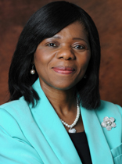 [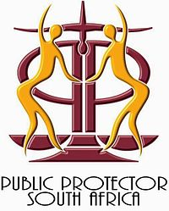](https://en.wikipedia.org/wiki/File:Public_protector_Emblem.jpg) 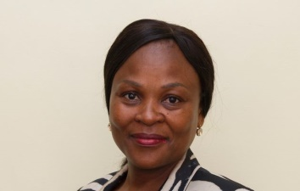

*Thulisile Madonsela Busisiwe Joyce Mkhwebane*

***RSA to quit ICC***

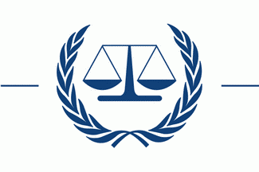On 19 October 2016, the Republic of South Africa formally applied to quit the International Criminal Court (ICC). In withdrawing from the ICC, South Africa reiterated its commitment to human rights and re-affirmed its commitment to continue to fight against any form of impunity for atrocities perpetrated anywhere in the world. Circumstances had led the South African government to conclude that to continue being a State Party to the Rome Statute would not be helpful in achieving its foreign policy objectives but would compromise South Africa’s efforts to promote peace and security on the African Continent and to play an essential part in international peacekeeping missions in Africa and in related peace processes.

***CITES COP 17 Conference***

**Science and wildlife conservation prevailed at the Conference of the Parties to the Convention on the International Trade in Endangered Species of Wild Fauna and Flora (CITES COP17) which was held in Johannesburg from 24 September to 5 October 2016.**

[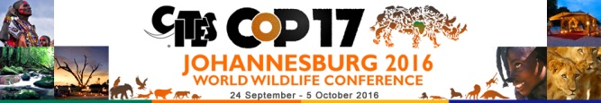](https://cites.org/cop17)

Over 2,500 delegates from about 180 countries attended **CITES COP 17. The conference** considered 62 proposals to change CITES trade controls affecting about 500 species and adopted recommendations and decisions: e.g. putting pangolin species into the highest category of protection; a ban on international trade in wild African grey parrots; the ban on sale of rhino horn; closure of the domestic elephant ivory trade.

For more details about CITES please see [www.citescop17jhb.co.za](http://www.citescop17jhb.co.za).

***National Marine Week***

National Marine Week was held in South Africa from 10-15 October 2016 under the theme ***Our ocean, our future***to raise awareness about South Africa’s marine heritage and the biodiversity supported by the oceans. South Africa’s oceans are home to the marine Big Five: whales, sharks, penguins, seals and dolphins.

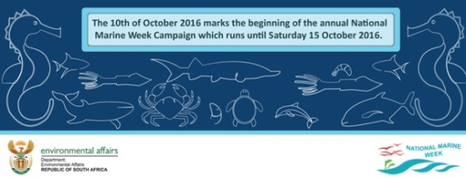

***Annual Diplomatic Funfair***

The Department of International Relations and Cooperation hosted the Diplomatic Fair on 29 October 2016 on the Union Buildings lawns, Pretoria, under the theme: *OR Tambo Lives! Celebrating the Life and Legacy of OR Tambo.* Embassies accredited in South Africa presented the art, music and cuisine of their countries.

[](http://www.dirco.gov.za/dipfair/index.html)

**CZECH NEWS**

***Elections in the Czech Republic***

Regional Government elections as well as partial Senate elections were held in the Czech Republic during October 2016.

***Outcome of Regional Government elections***

ANO won the elections in 9 out of the 13 contested regions (Central Bohemia, Pardubice, Hradec Králové, Plzeň, Karlovy Vary, Ústí nad Labem, South Moravia, Olomouc and Moravia-Silesia); the Czech Social Democratic Party (ČSSD) won in 2 regions (South Bohemia, Vysočina); the Christian Democratic Union – Czechoslovak People’s Party (KDU-ČSL) won in Zlín region and Mayors (SLK) in Liberec region.

The turnout was 34.6 %, 2.3 % lower than 4 years ago.

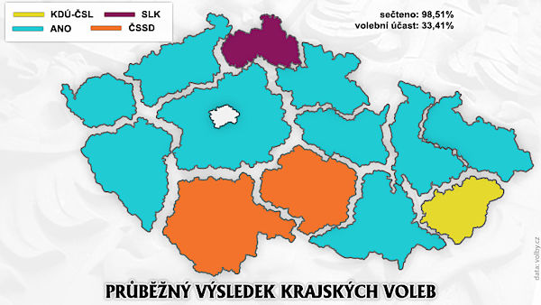

**Election results of the main parties**

|  |  |  |
| --- | --- | --- |
| **Party** | **No of votes** | **% of votes** |
| ANO | 533,061 | 21.05 |
| ČSSD | 386,150 | 15.24 |
| KSČM | 267,047 | 10.54 |
| ODS | 239,836 | 9.47 |
| KDU-ČSL | 159,610 | 6.30 |
| SLK/STAN(Mayors) | 101,696 | 4.01 |
| TOP 09 | 86,164 | 3.40 |

Following the elections, the parties negotiated to form coalitions. In three regions, coalitions were formed excluding ANO that won the elections (Pardubice, Hradec Králové and Plzeň). Negotiations in some regions still continue.

***Senate elections***

[](http://www.senat.cz/index.php?ke_dni=7.11.2014&O=9)

The turnout of senate elections was 33.5 % in the 1st round and 15.4 % in the 2nd round; the lowest since the establishment of the Senate in 1993.

KDU-ČSL won the senate elections by gaining 9 of 27 Senate seats contested. ANO, ODS and Mayors (STAN) won 3 seats each. ČSSD, TOP09 and regional group North Bohemians won 2 each. The Greens and two regional groupings gained 1 seat each and the Communist Party (KSČM) failed to win a single seat.

The government coalition consisting of ANO, ČSSD and KDU-ČSL gained 14 seats altogether and retained the majority in the upper Chamber.

|  |  |  |
| --- | --- | --- |
| Political party | No of senators | No of seats defended |
| KDU-ČSL | 9 | 2 |
| ANO | 3 | 0 |
| ODS | 3 | 8 |
| STAN | 3 | 0 |
| ČSSD | 2 | 12 |
| TOP09 | 2 | 2 |
| North Bohemians | 2 | 2 |
| Others | 3 | 1 |

***Celebrations of late President Havel anniversary***

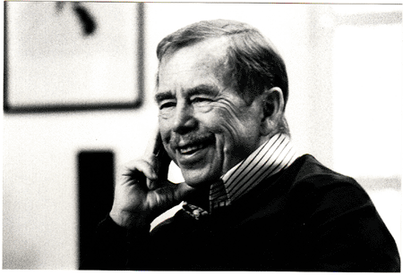

Václav Havel

**5/10/1936**

**18/12/2011**

1989-1992 President of Czechoslovakia

1993-2003 President of the Czech Republic

Numerous events were held in the Czech Republic and abroad to mark the 80th anniversary of the birth of Czech dissident playwright and statesman Václav Havel.

A special concert in his honour was held in Rudolfinum, Prague on 5 October 2016 and a rally called *My Fellow Citizens* was held in the city centre on the same day. Exhibitions of Václav Havel’s photos and work were displayed at various places; his plays were performed; Havel benches installed; a bust unveiled etc.

A little square between the old and new buildings of the National Theatre in Prague bears his name since 4 October 2016. A big granite heart by sculptor Kurt Gebauer was installed there for people to write messages.

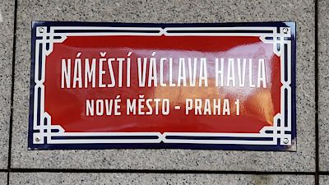 [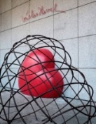](http://i1.wp.com/www.tresbohemes.com/wp-content/uploads/2016/10/Vaclav-Havel-Monument-Tres-Bohemes.jpg)

The celebrations culminated a concert in Lucerna Palace where symbolically 80 singers, actors, musician and writers performed.

The Václav Havel Human Rights Prize was awarded to Yazidi human rights activist Nadia Murad on 10 October 2016.

Nadia Murad was a guest of honour at a conference *Fences, Walls and Trenches: Freedom of Movement as a Human Right* held by the Václav Havel Library at the Prague Crossroads on 12 October 2016.

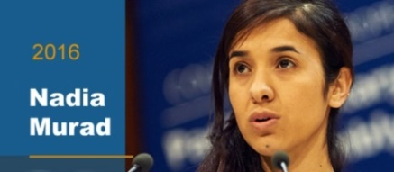

***Forum 2000***

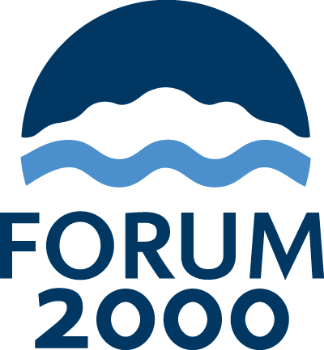The 20th Forum 2000 Conference was held in Prague and other Central European cities from 16–19 October 2016. The Conference pursues the legacy of Václav Havel by supporting the values of democracy and respect for human rights. Slovak President Andrej Kiska, Garry Kasparov, as well as President Václav Havel’s friend, Tibetan spiritual leader, His Holines the Dalai Lama addressed the conference.

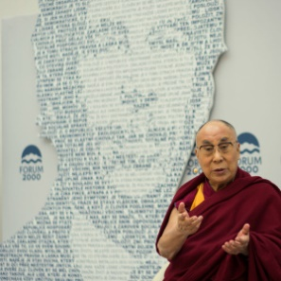

*His Holiness*

*the Dalai Lama*

*speaking at a Forum 2000 panel on The Paradox of Religion, Prague,*

*18 October 2016.*

*Picture: Forum 2000*

The Dalai Lama held public talks entitled *Secular ethics* at Lucerna Palace in Prague; he met Minister of Culture Daniel Herman and other representatives of the KDU-ČSL, as well as Czech Parliamentarians at the Senate.

***National Day celebration***

On 28 October 2016, the Czech Republic celebrated the 98th anniversary of the foundation of independent Czechoslovakia. On this occasion, President Miloš Zeman presented state honours and decorations at Prague Castle to 30 personalities, some of them in memoriam. War veterans, artists, politicians, diplomats and businessmen were among the recipients.

The day before, on 27 October 2016, President Zeman received the congratulations and best wishes from the Heads of Diplomatic Missions accredited to the Czech Republic at a reception at the Castle.

***George Brady awarded***

88-year-old Auschwitz survivor George Brady, uncle of Minister of Culture Daniel Herman, was not awarded at Prague Castle, but he received many other awards and distinctions. Prime Minister Bohuslav Sobotka presented him with Karel Kramář Memorial Medal for his life long fight for Holocaust remembrance; he received the key of the Capitol of Prague from the Mayor of Prague Adriana Krnáčová; medals from the Lower House, Czech Post Bellum NGO, Palacký University in Olomouc, Mayor of Brno and Mayor of his home town Nové Město na Moravě.

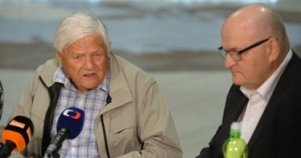

*George Brady and Culture Minister Daniel Herman.*

More than 15 thousand people, including politicians, university dignitaries and people from show business expressed their support for Mr Brady at a National Day celebration at the Old Town Ring on 28 October 2016.

***Signal Festival in Prague***

The fourth Signal Festival of light art ran from 13–16 October 2016 with 23 installations across Prague. The show featured animated movies, video-mappings, interactive art and several light installations.

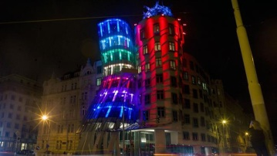 [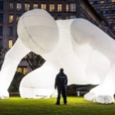](http://www.signalfestival.com/2016/installation/fantastic-planet-3/) 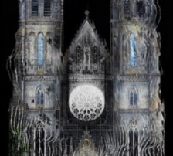

|  |
| --- |
| For more information about the activities of the South African Embassy in Prague please visit our website: http://[www.saprague.cz](http://www.saprague.cz) |